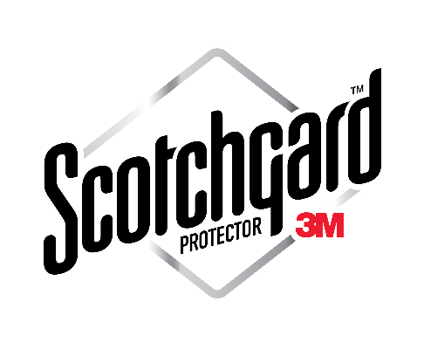
12 Month Carpet “Spot and Spill”
Limited Warranty
Issued To: _________________________________________________ Date: ____________________________
Address: _________________________________________ City: ____________________ Zip: _____________
Phone: _________________________________ Cell: _____________________________________________
What is covered:
This Limited Warranty provides free spot and spill removal calls for common house hold “food and drink spills” for 12 months from above date. This warranty covers the areas that we cleaned and protected with Scotchgard as per our attached invoice # ____________________.) This warranty does NOT provide free spotting calls for:
- Pet urine, feces or vomit removal
- Dirty and/or worn “traffic lanes”
- Oil-based stains
- Water or sewer damage
What you need to do:
1) Take immediate action. Blot up as much of the spill as you can. (Call us anytime for free over-the-phone advice.)
2) Follow the instructions on your Free Lifetime Spot Out bottle we left after cleaning your carpets. (Test the Spot Out first in a closet.) After removing the spot leave several thicknesses of white toweling on your carpet with a heavy weight (books work well) on top to adsorb the rest of the material. (You may need to change out the toweling several times.)
NOTE: Please do NOT use any other type of carpet spotter other than the Spot Out we provided. Doing so may void your “Spot and Spill Warranty”. (For a free replacement bottle of Spot Out just give us a call.)
3) IF you still can’t remove the spill with your Spot Out (the vast majority of spots will come out easily!) then just call us within 24 hours after the accident. We will send a technician out as soon as possible- no charge!
Special Note: This warranty does NOT guarantee spot removal since some spills may be permanent stains. However, all professional efforts will be used on your Covered Areas to restore your carpet at no charge to you.
Offer applies only to professionally installed, wall-to-wall residential carpet. Commercial and tenant occupied properties are not covered.

How to keep your “12 Month Spot and Spill” coverage in effect:
This free “Spot and Spill Warranty” expires on ____________________ . To maintain your “Spot and Spill” coverage simply schedule us in to clean and re-apply Scotchgard protection to your carpets. This will renew your “Spot and Spill” warranty for another 12 months- FREE OF CHARGE!
Representative’s Name: _____________________________________________________ Date: _______________

